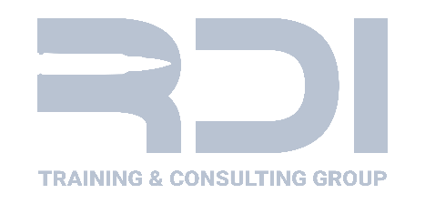
Tactical Shield – Solo Operator Course – TCOLE #3390

Event Type: Law Enforcement Career Development
Start Date: Thursday, May 21, 2026 – 08:00
End Date: Friday, May 22, 2026 – 16:30
Audience: Corrections, Peace Officer, General Public
Hours: 16
Cost: $325.00
The Tactical Shield Solo Operator Course is crafted to ensure patrol officers are not only equipped with tactical shields but also skilled in leveraging their benefits across various law enforcement scenarios. This training provides an in-depth examination of the practical uses of tactical shields, equipping officers with the knowledge to exploit their strengths, recognize their limitations, and bolster their operational response in high-stress situations.
Participants will undergo drills encompassing a wide range of response tactics, effective shield deployment strategies, and synchronized team maneuvers. A critical component of the course is a live-fire exercise, designed to instill confidence and competence in officers, enabling them to handle dangerous situations using a ballistic shield for personal defense. The course underscores the necessity of skill mastery in addition to equipment possession, focusing on the critical importance of proficient equipment use for an effective law enforcement response to critical situations.
Student will need:
Pistol w/3 pistol mags 100 pistol ammunition
Rifle w/3 rifle mags (optional) 100 rifle (optional)
Patrol based equipment Eye and hearing protection
Agency issued shield if issued Clothing appropriate for the weather
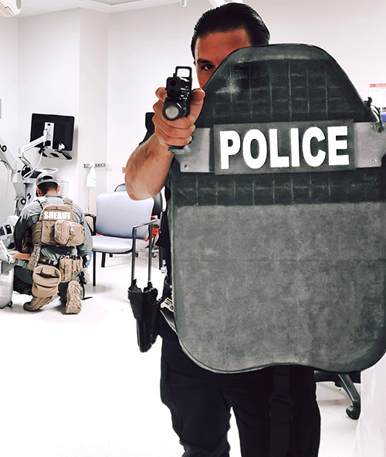
Food and water

Instructor Name:
RDI Instructors

Location:
UTSA Downtown Campus

Address:
Monterey Building
501 S Frio St
San Antonio, TX 78207

TCOLE hours are reported directly to TCOLE. All RDI courses are constructed and maintained per TCOLE standards and eligible for TCOLE credit.

